ANSWERS(ASSIGNMENT 9)

1)
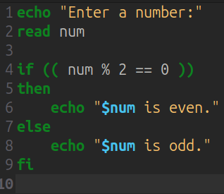
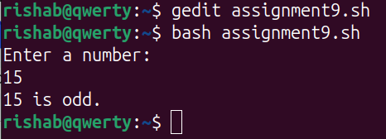

2)The if statement evaluates the exit status of a command or expression, executing the then block if the status is 0 and optionally the elif or else blocks for the next conditions. It checks each condition in sequence until one evaluates to true, making it suitable for complex logical tests involving comparisons, arithmetic, or pattern matching with [[ ]]. However, this sequential evaluation means every condition in a chain is tested until a match is found, which can be inefficient with many conditions. In contrast, the case statement evaluates a single word (often a variable) against a list of patterns and executes the first matching block, then stops immediately. This makes it ideal for testing a variable against multiple fixed values or patterns, such as command-line arguments, user input, or file extensions. The syntax is cleaner and more readable

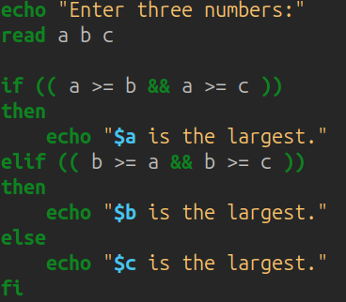
3))
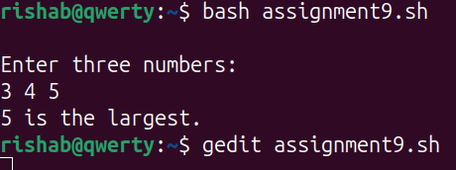

4)
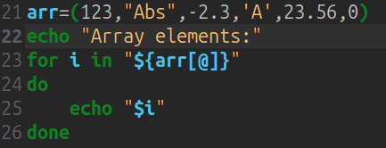
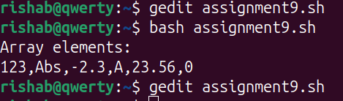
5)
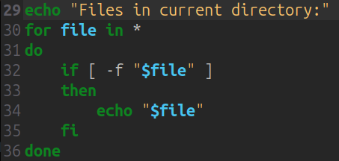
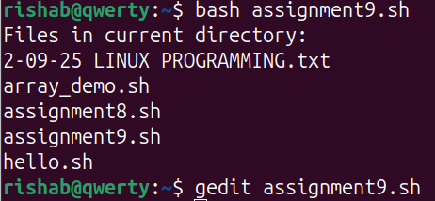

6) WHILE loop
It will be executed as long as the condition is true.

UNTIL loop
It will be executed until the condition becomes true.

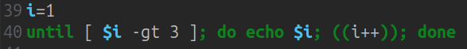
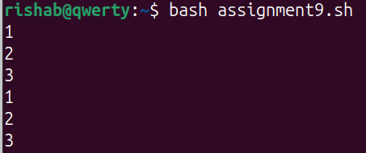
7) For countdown
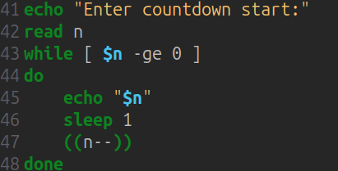
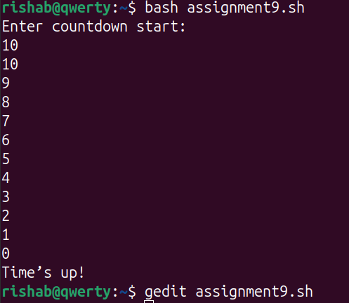
8)Break and continue statements are used to control loop execution. Break exits the loop, while continue skips to the next iteration.
These statements are typically used inside conditional blocks to alter the flow of the loop.
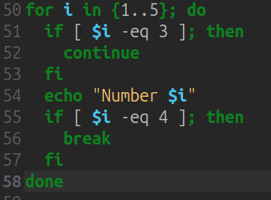
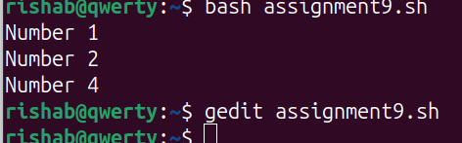

9)

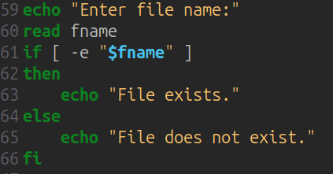

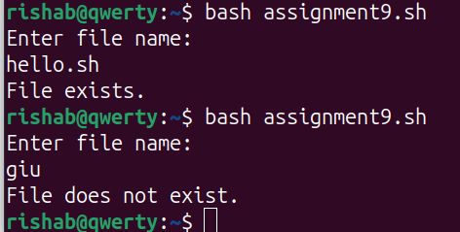

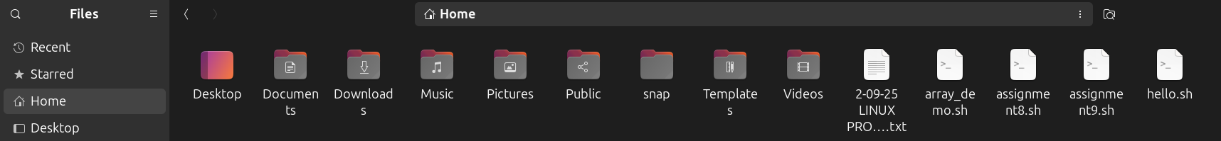

10)
